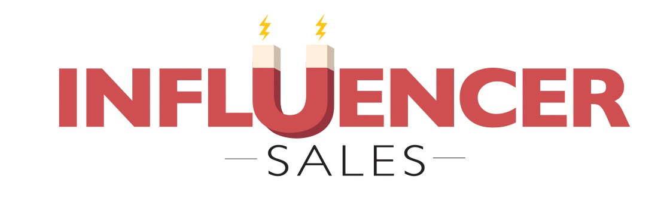

**Building Your Account**

**Touchpoint Blueprint**



**Introduction**

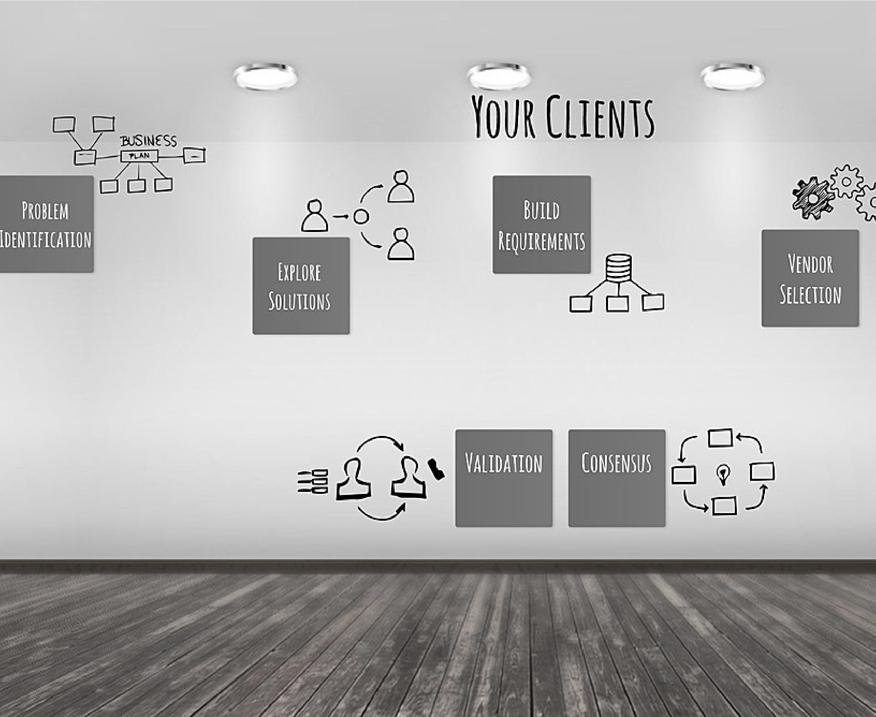This workbook allows you to think through key elements for building your account touchpoint blueprint. The more thought you put into this up front, the more useful this will be in the future, so take a few minutes and really think it through.

You may not know all of the answers and that is okay. Fill in what you know now and then use the resources you have learned to fill in more.

# Step One

Give us the background of your selected account. Just bullet points. We want to see the basics what they do, how well they are doing, their current relationship (summary only) with you. You can also list out any goals you might have for them this year - production, progress, you decide.

**Give us a summary of your account. Who they are, what they do, their history with you and any goals you have for them for this year (and yes of course you can pull from your existing account plans!).**

# Step Two

We are going to move into their SWOT analysis now. Start with Strengths and Weaknesses. Again, bullet points. Strengths and weaknesses generally refer to internal issues.

**Strengths**

**What does this client do well in compared to the rest of their industry? Why are they a leader, what are their differentiators? Consider their mission, goals, competitive position, culture.**

**Weaknesses**

**Every organization has them - what keeps this account's CEO up at night? What do their competitors do differently? Weaknesses typically deal with internal challenges - has their been turnover at the top? Why?**

# Step Three

Now let's take a look at their Opportunities and Strengths. These usually are external - what is going on in the world that may be impacting them? How has Covid changed the way they do business?

**Opportunities**

**What are their best chances for growth this year? Is there new demand for their products? From where?**

**Threats**

**What is their biggest external threat? What could harm them most? Government policies? Enviromental changes? Tech challenges? New competition or disruptors?**

# Step Four

Now let's take a look at your SparkToro Research. What trends did you discover? What are their top websites, podcasts, social sites and influencers? What keywords are trending for them? This will drive your content.

**Top Websites and hidden gems, top podcasts, top social accounts**

**Top Influencers and trending keywords**

**What people should you be following to keep with with this segment? What keywords are currently trending?**

# Step Five

ZoomInfo/LinkedIn Research

**Tell us the key decision makers and influencers inside of this account/segment just their key info (name, title, role as it pertains to working with you).**

**Targets**

**Who are some people you would like to target within this account/segment?**

**Please list their key info (name, role, why a target).**

# Step Six

Corporate Programs - Based on what you have learned about the sort of content this account follows and posts, what programs might hold the most interest for their culture? Please also include what and why they might finding appealing about your programs. For example, their culture is all about empowering women or sustainability, so we should highlight those programs or stories we have.

**Corporate Programs - What and Why?**

**What programs might this account find most appealing and why? Be sure to think about all of your existing programs - and also new hotel openings and brand types.**

On the following pages, please think about one or two of your primary decision makers/contacts/influencers within this account. Answer the following buyer profile questions – using LinkedIn and Crystal Knows for additional insights.

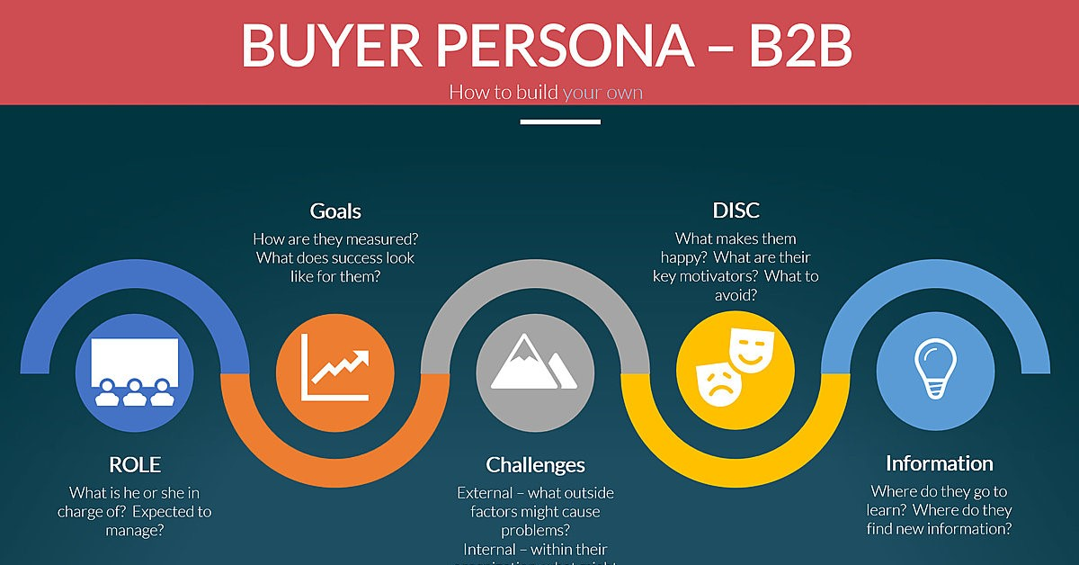

*“Effective messaging emerges at the*

*intersection of what your buyers want to*

*hear and what you want to say.”*

Adele Revella

Answer

Answer

Answer

Answer

Answer



Buyer Profile

Customer Name and Role

Goals and Measurement

DISC Highlights

Pain Points/Challenges

Information Sources



Ideally you will want to create a buyer profile for every one of the existing or

targeted key contacts you have. For this account, complete at least one or two on

the following pages from your account or segment.

Answer

Answer

Answer

Answer

Answer

Buyer Profile

Customer Name and Role

Goals and Measurement

DISC Highlights

Pain Points/Challenges

Information Sources

Content Calendar Ideas

Jot down any ideas for content you would like to share with the account/segment

based on the previous pages. Any hotel openings they might like? Any special

events they will want to know about? Any program info you want to share? Of

course add in the typical holiday touchpoints as well.

June

Content Ideas

July

Content Ideas

August

Content ideas.

September

Content ideas.

October

Content Ideas

November

Content Ideas

December

Content Ideas